Benjamin Jusufovic
Curtis Mayberry
Thinh Luong
Ben Cao

Week 3
Purpose:
The purpose of this report is to highlight the progress that our team has made in the initial steps of our senior design project (F10-19).
Progress:
Throughout week 3, our group has met on three different occasions. We split the project up into two pieces –the user interface and the valve controller unit. We then created the following high level block diagrams:

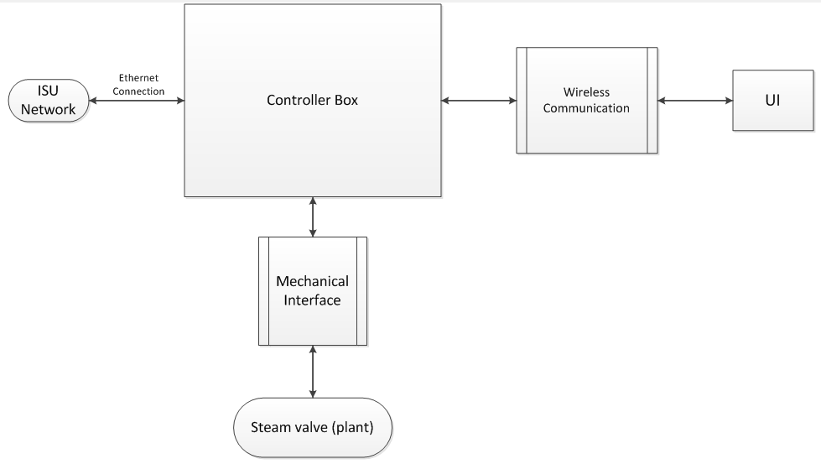
Figure 1: High level block diagram of overall design.
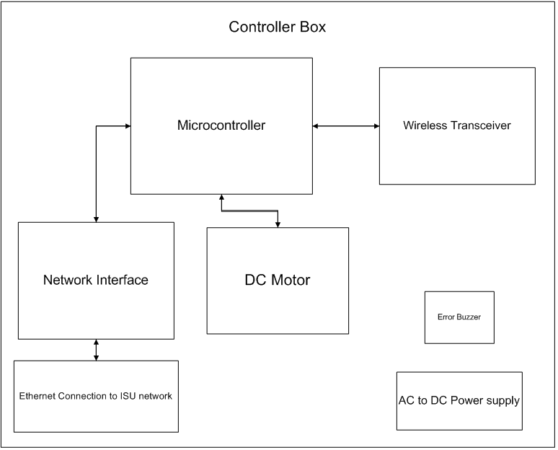

Figure 2: High level block diagram of valve controller design.

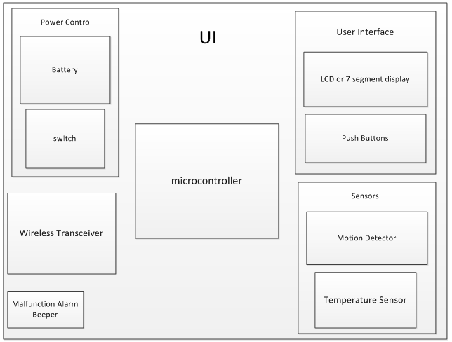

Figure 3: High level block diagram of user interface design.

We will be meeting this Tuesday to discuss project cost analysis and attempt to map out costs for the remainder of the project life in order to remain within / under budget.
Closed issues
- Determined feasibility of dc motor for mechanical implementation
- Measured needed torque to turn steam valve
Pending issues
- Find appropriate product that meets availability, specifications, and cost budget
- begin high level documentation of mechanical implementation for project plan

